Chip Production activation tutorial

- You need to run packaging.py script (Located in ‘scripts’ directory) to get a new zip that pack all you need to run the algorithm.
While running the script will ask you if you want to upgrade version and you need to type ‘n’ for no or ‘y’ for yes (of course without the apostrophes) if yes you will ask to enter h/m/l for which
Place you want to change (h/m/l stands for high/middle/low), and now you need to wait for roughly 4.5 minutes until the zip will be prepared.
Now were the zip will created determined by ‘packaging_config.json’ file (which also located in ‘scripts’ directory), This file determines for packaging.py where to find each file its needed and in addition it also determines were to put the result zip,
This configuration file look like this:
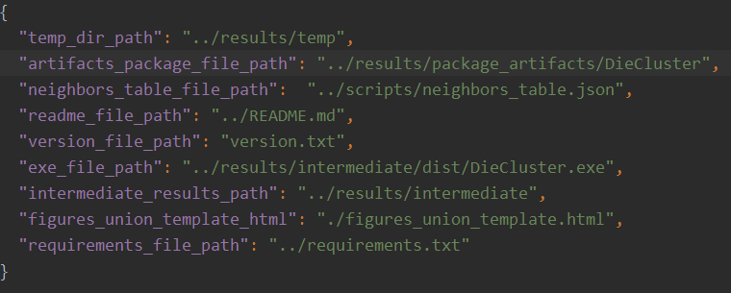
When each row is of the form “key”: ”value” when key describes the relevant property, and value is the value we want the algorithm to use.
In particular:
“artifacts_package_file_path” is were to put the result zip, and which name we want to give him, "../results/package_artifacts/DieCluster"
Says that the zip would lie in folder ‘package_artifacts’ and its name will be DieCluster
[ In fact I add for the zip name a date and version].

- Now extract all the files from the .zip into special directory (Its very important that all files will lie in same directory so the code will know were to find them),
now your directory should look like this:
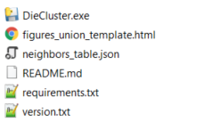
- A) version.txt file contains the version of the package.
B) requirements.txt file contains all packages that aren’t python standard packages, which means, that if you try to run the code via command line or code editor you will need to install them, But to run the .exe file you shouldn’t install anything, In addition PyInstaller package, which we use in our code in the packaging process, Have problems with specific versions of some packages, If this happen you need to downgrade those packages, to know which packages
cause this you can find all my environment (my packages versions) in GitHub in issue 44
Here https://github.com/Vayyar/ChipProduction/issues/44 .
And you can simply compare your environment to mine, to find packages that cause the problem, and then simply downgrade them.
C) README.md is the same to the README from GitHub and contains explanations on the
project, and its purpose.
D) ‘neighbors_table.json’ determines how many die neighbors need some chip to have so that the algorithm will declare on him as die.
And its looking like this:
{
"0": 1,
"1": 1,
"2": 1,
"3": 2,
"4": 3,
"5": 3,
"6": 5,
"7": 5,
"8": 6
}

When each row is “a”: b when “a” is the number of neighbors, the chip have, and b is the threshold of the minimal number of die chips in it 8 neighbor, we need to mark him as die.
This file you must change to whatever you want to before applying the algorithm.
E) ‘figures_union_template.html’ is skeleton file the algorithm uses for generating the .html file.
F) DieCludter.exe this is the application you simply need to double click on it to start the application, this will open a window which manage the algorithm.

: APPLYING THE ALGORITHM:

- Don’t forget to update neighbors_table.json file with the real threshold (See explanation In 3 D above).
- Now Double click on DieCluster.exe file to open a window, it should look like this:

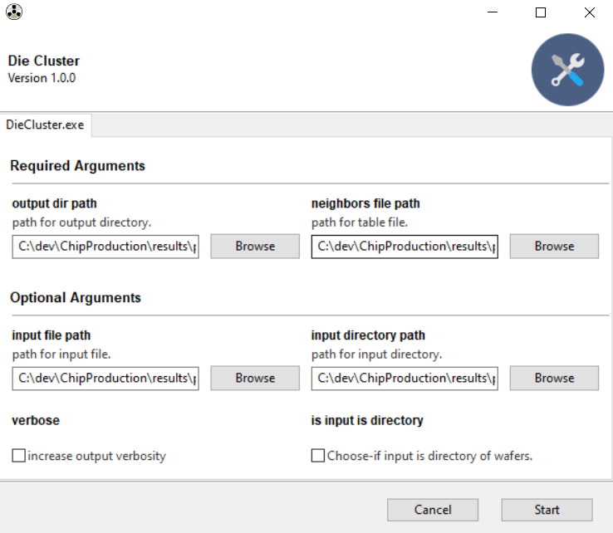
- Now all you need is to fill the relevant boxes with correct values and surprise surprise press on the “start” botton.
- So lets mark each box with identifier number just for clarity of the below explanation
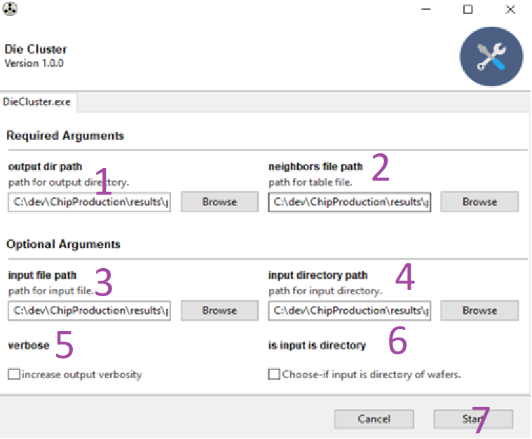

Region 1: Here you should insert path for a directory were you want the program will put its results
(If the path currently not exist, the program will create it).
Region 2: Here you should insert path for the json file that contains the threshold data
as explained in 3 D above.
If you rely on the json that attached with the zip, you don’t need to change here anything
the default path is correct, (you need change it only if you rely on another json with different place or with different name).

Region 6: The input for the algorithm can be a single file, or a directory of wafers, or even directory that contains directories that contains wafers, and so on.
(If the input is directory the algorithm will pass on all files in the directory in one run
and will create also a summary excel).
So if the input is full directory of wafers you should check this box, else (if it a single file)
just remove it unchecked.

Region 4: If you leave box 6 unchecked, you may simply ignore this box (The program will ignore it), else just insert here the path of the directory that contains all the wafers
Please pay attention that this directory should contains only wafers (or directories that contain directories that contain wafers and everything like that), and not anything else.
Region 3: If you leave box 6 checked you may ignore this box (The program will ignore it), else just insert here the path of the wafer file (it can be either .txt or .stdf file).
Region 5: For now it simply deed area (Historically It was responsible to rule if the screen will display only INFO or also DEBUG messages when running, but finally I change it so that always it will display also DEBUG messages, it very easy to change it back if you wish, or to delete this area, with small changes in main.py script).

Region 7: Finally, just click start to run.

After successful run you need to see something like this:
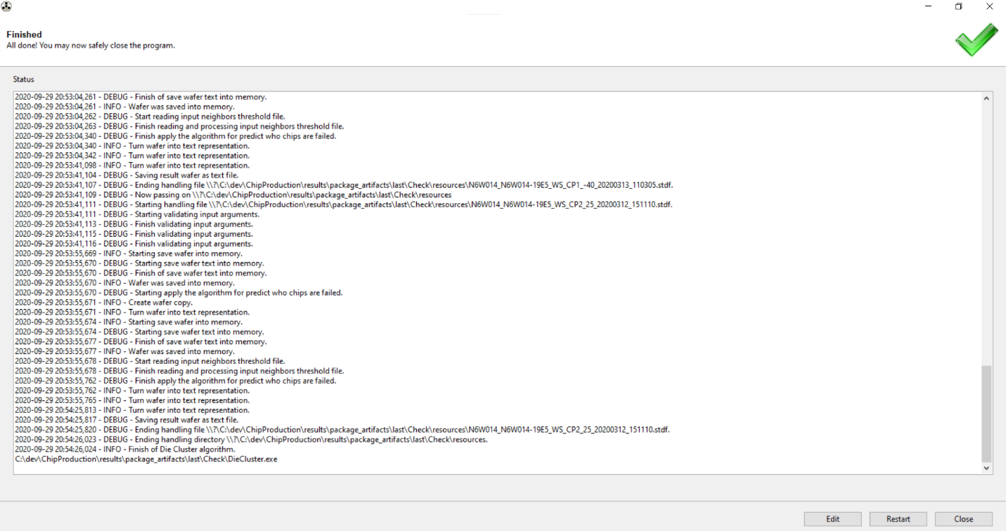
The results lie where you told the program to put them in region 1
Here example of how the program results should look like

And the html files should look likes
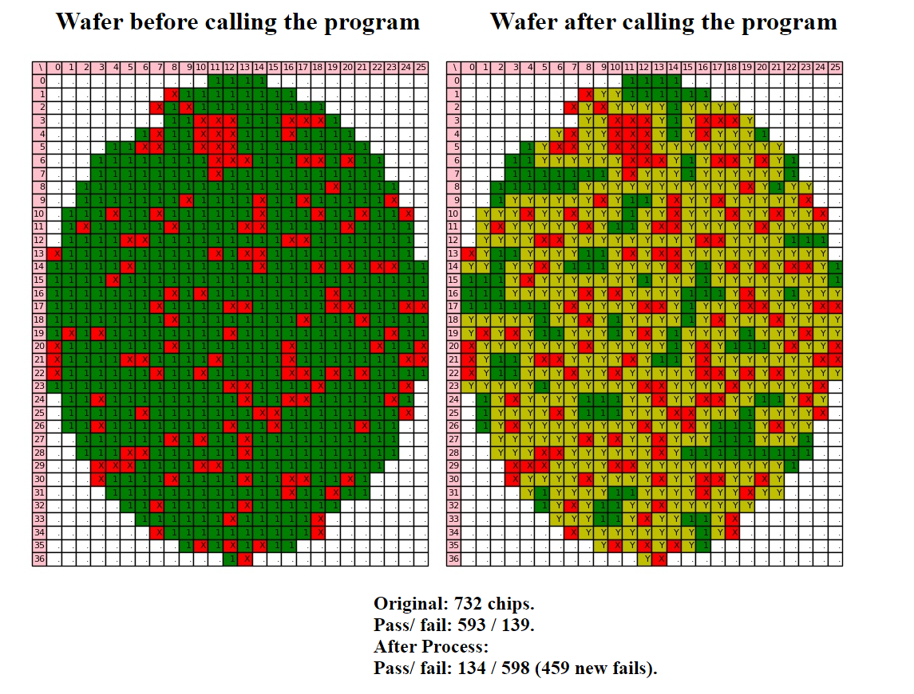

Comments:
- Efficiency: there are huge difference in running time between the program if we run it as .exe file, or as .py file by simply running main.py script, when the later is quicker in order of magnitude, so it may worth considering to run it through main.py (its also create a GUI window)
when there are huge amounts of wafers.
- Efficiency: The vast majority of the time (something like 97%) taken by the savefig method of matplotlib package (Used in HtmlViewer.py file in scripts directory), that saves the figures which latter I plant in the html file (I mean the wafer figures).

- When trying to make things parallel (In attempt to save time) the Gooey (which create the GUI window) get very crazy with problems that I find very hard to solve.

